dddddddddTeam 3

**Software requirements specifications**

**California State University Northridge**

**October 12, 2016**

Presented by: Ramon Bautista Jr, Miguel Sanchez, Omogbolabo kupoluyi, Kevin Enario, Babak arian, Louis Wagner



Degree Planer

**1. Introduction**

**1.1Purpose of This Document**

The purpose of this document is to present a detailed description a Software System that will resolve issues that prevent students from graduating in a timely manner at California State Universities. It will explain the purpose and features of the system, the interfaces of the system, what the system will do, the constraints under which it must operate and how the system will react to external stimuli, and what outside sources if any the system will need for it to be implemented as well as which audiences are affected by such software. This SRS is intended for both the stakeholders and the developers as well as any other parties of interest. This document is intended to be presented for but not limited to COMP 380 MW class.

**1.2 References**

PHD. Thayer, Richard Hall, PHD Dorfman, Merlin, (2013). Software Engineering Essentials. Carmicheal, California: Software Management Training Press.

**1.3 Purpose Of The Program**

The Degree Planner (DP) is to provide students with the proper resources to give them a better chance to graduate within the four year expected time.  The DP will help students choose their classes from semester to semester depending on their major. Once the student has chosen classes for the semester the software will analyze the students’ classes (past and current) and will then suggest a class schedule that has the best outcome to graduate on time. It will also generate a suggested schedule based on past students who have taken those classes and give a schedule that is formulated best to ensure there graduation success (e.g. if students passing rate was found higher by a specific instructor, the course that had the higher passing rate would be put in the suggested schedule) . Aside from finding the best schedule to help students graduate on time, the software also reminds students when their registration date is and prompts those if they need to take the upper division writing test. It will provide links to help students with financial issues, such as where to get loans or apply for scholarships.

**1.4 Product Scope**

In this software a student as main user, will create a plan based on current information regarding her/his major. The Degree Planner System, through a Survey will ask user to input detailed information, which can useful to create and optimize a plan. Faculty such as counselor will act as a controller (authorized faculty) whom is outside of the software boundary, has access to this software via the features: Plan (Program/Major), Get Class, Compare Workload, and Optimize Schedule in order to optimize some part of plan which software cannot optimize automatically.

On the other side of software boundary, there are two databases; the College Database, and U.S. Bureau of Labor Statistics Database. Degree Planner System connects to a U.S. Bureau of Labor Statistics Database in order to getting job and career information about a major. So a student can see this information when she/he wants to create a plan. The software uses the College Database as the main reference. Therefore, most segments of Degree Planner System have a permanent connection with this database and they collect some information regarding students and colleges such as class schedule, prerequisites, grades, and etc.

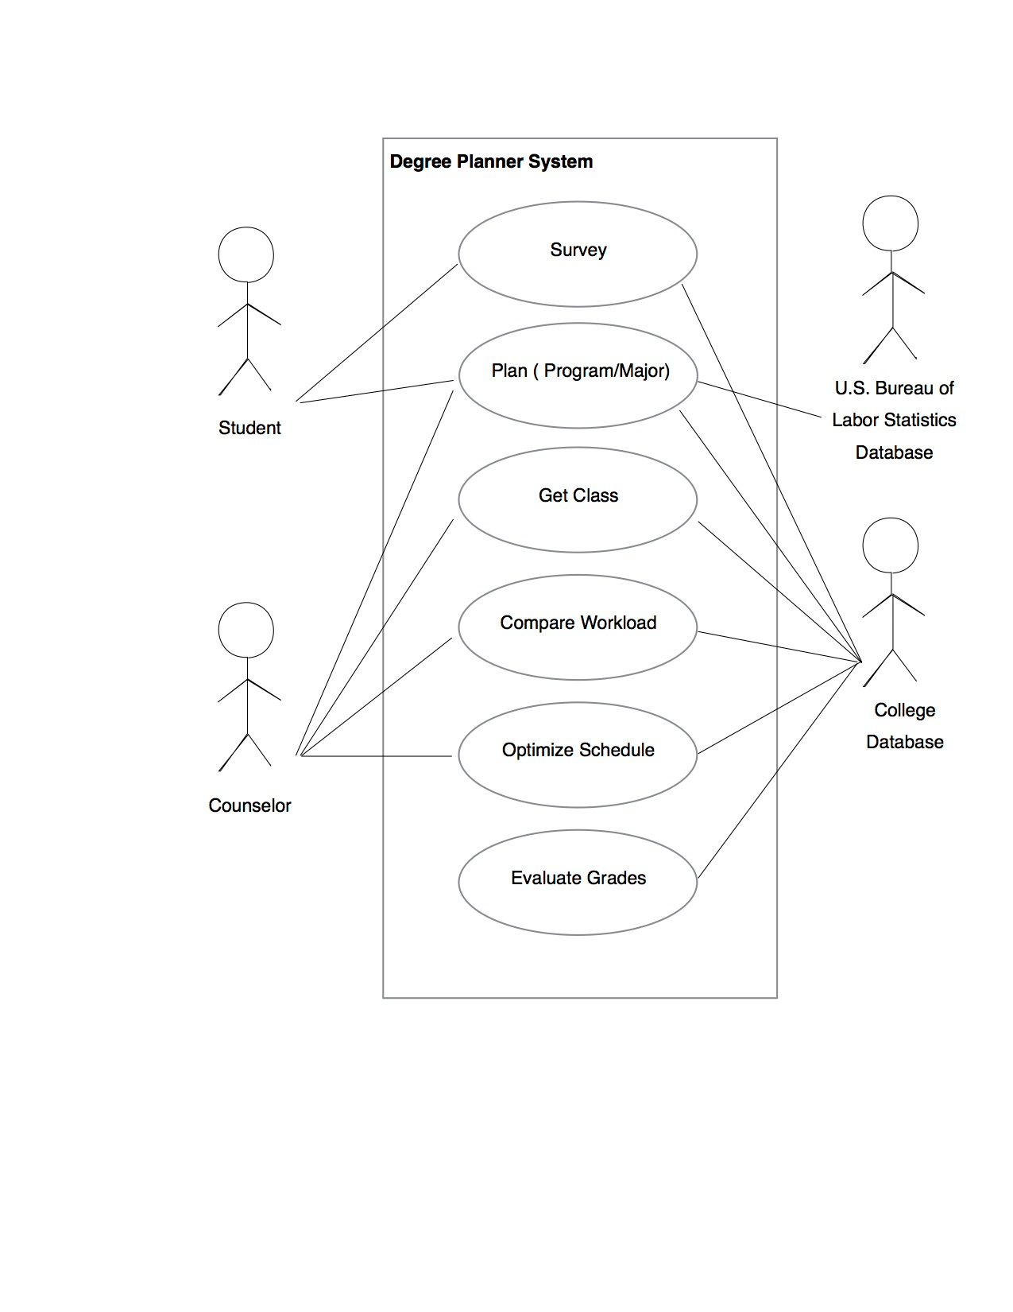

2.

|  |  |  |
| --- | --- | --- |
| **Number** | 2 | |
| **Name** | Plan Degree ( Program/Major) | |
| **Summary** | Create a plan degree | |
| **Priority** | 6 | |
| **Preconditions** | User has logged into the CSUN Portal | |
| **Postconditions** | User has submitted in order to create a plan degree | |
| **Primary Actor(s)** | Student, Counselor | |
| **Secondary Actor(s)** | College Database, U.S. Bureau of Labor Statistics Database | |
| **Trigger** | user has selected "Plan ( Program/Major)" | |
| **Main Scenario** | **Step** | **Action** |
|  | 1 | System displays list of Program/Major |
|  | 2 | User chooses one from the list |
|  | 3 | System displays the major and detail ( such as total units required, career information, wage, benefit and etc.) |
|  | 4 | System displays list of related majors |
|  | 5 | User chooses a continue button or back button |
|  | 6 | System asks for some details ( expected graduation date, year of an educational, and etc.) |
|  | 7 | System asks for submit and show message “process can take up to 24 hours” |
| **Extensions** | **Step** | **Branching Action** |
|  | 4a | User can change mind and chooses another major |
|  | 4b | Anytime user can change mind and back to first step |

**3. Non-Functional Requirements**

|  |  |
| --- | --- |
| Name | Minimal bugs and contingencies to crashes |
| Type | Reliability |
| Priority | 1 |
| Description | The system is running with minimal bugs (Running without imperfections to the user, bugs may exist for optimization and performance), never crashes, and has feedback and documentation in regards to crashes (students and faculty can provide feedback to any issues via Email @ Team_3@my.csun.edu) |

|  |  |
| --- | --- |
| Name | 24/7 access Exception every second Saturday of every month two hour routine maintenance is performed |
| Type | Availability |
| Priority | 2 |
| Description | The degree planner is accessible at all times of the day to allow students to use it at any time that they want. |

|  |  |
| --- | --- |
| Name | Support for multiple websites |
| Type | Portability |
| Priority | 3 |
| Description | The software is compatible on, Mozilla Firefox, Google Chrome, Safari, and Internet Explorer (All current versions) |

|  |  |
| --- | --- |
| Name | Accuracy and Precision |
| Type | Effectiveness |
| Priority | 4 |
| Description | The software is as close to accurate and precise based off of student surveys, updated university major requirements, and Team 3 schedule defined algorithms.To give the student the most effective paths for graduating in time. |

|  |  |
| --- | --- |
| Name | Efficient and Fast |
| Type | Response Time |
| Priority | 5 |
| Description | The software responds smoothly (navigation and usability of the software can be considered a “pleasant” experience by the average user, complaints can be addressed at Team_3@my.csun.edu), allowing for effective use of time. |

**4. User Interface**

See “User Interface Design Document for your product name.” here. We will address the User Interface Design later.

**5. Deliverables**

Deliverables are what will be provided to the customer. The items will be delivered to the customer via email with a link to access the download for files. The email should be sent within two weeks to give time to set up the degree planner for use for the customer.

Website access for:

Degree Planner

Degree Planner Ticket Support

PDF documents:

User Manual for Student and Professors

User Manual for Administrators

Media Files:

Degree Planner Support Video; An instructional video which provides a prerecorded tutorial on how to navigate through the software. It has both visual and audio narrations.

Services offered:

Support for authorized administrative personnel; 24-hour email access to Team_3@my.csun.edu, to provide feedback to issues and/or possible improvements.

**6. Open Issues**

Survey

Determining the quality of your survey data, looking out for cheaters and speeders. Cheaters pay little or no attention to the survey questions; they look for a pattern in your first few questions and then respond to all questions with a corresponding pattern. Speeders finish the survey far more quickly than anyone else. For example, they spend only a few seconds on a usability task that takes much longer to complete, or they finish a thirty-question survey in a few minutes. Having these types of “faulty” survey’s will be a continuing issue for the software to offer reliable and accurate survey information to students. The biggest issue would be how to filter out as many “faulty” surveys as possible. Problems related to this issue are described next.

Understanding the impact of missing data; If the missing responses being to seem identical or similar to certain types of respondents (students failing course), the results could be unexpectedly biased. Techniques exist for filling in missing data: inputting values, using the mean, using regression analysis, or using values determined from other responses

Passing and failing rate

Examine distributions, not just averages; The mean tells you about the middle or typical value, and the standard deviation describes the variability. It's also helpful to see how the data is distributed using a frequency distribution (for discrete data) and a dot-plot (for continuous data

Handling bugs and error checking in design modalities

What happens when something goes wrong? It will be a continuing effort to optimize the software, in fixing bugs, improving user interface, updating major requirements, and addressing performance issues. To that we say not all problems are unexpected. The user can often anticipate potential problems (like a nonexistent file or the wrong type of input). Communicating these problems to the user is the job of conditions: errors, warnings, and messages. By communicating these problems, the user can take action based on those communication (tips/hints) to execute the software successfully based on its functional/ Non-functional attributes.